**Create an account in TFE CLOUD**

<https://app.terraform.io/public/signup/account>

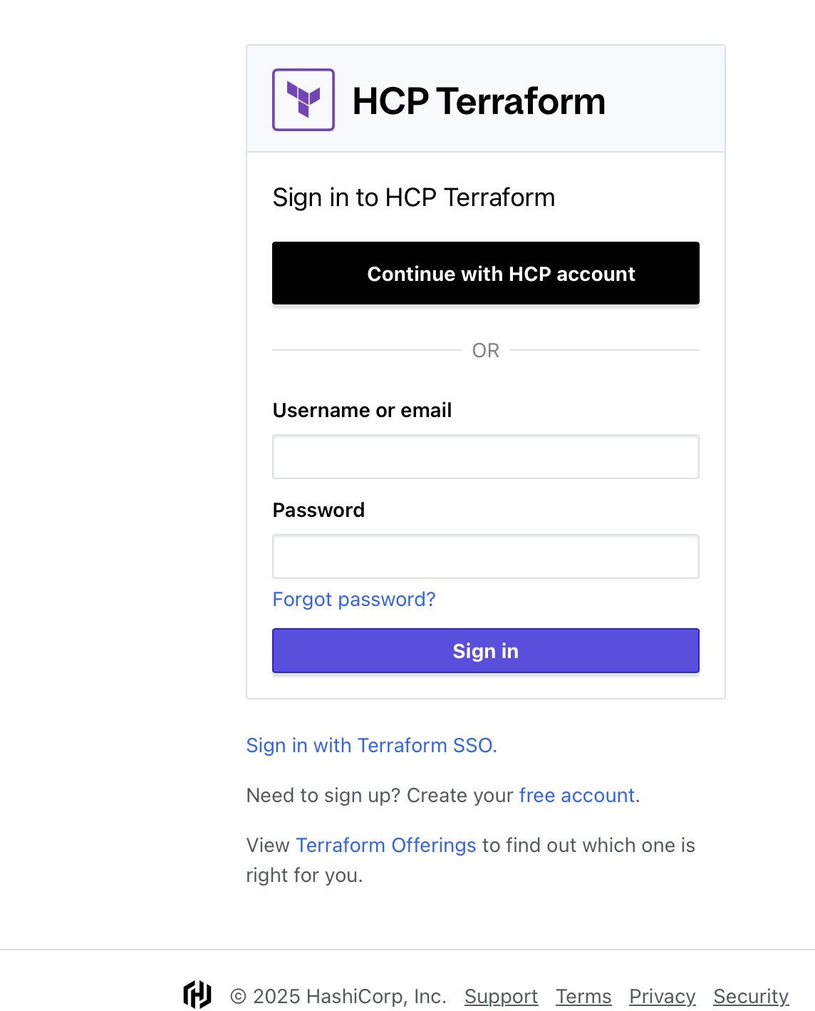

Click on free account. Enter your details

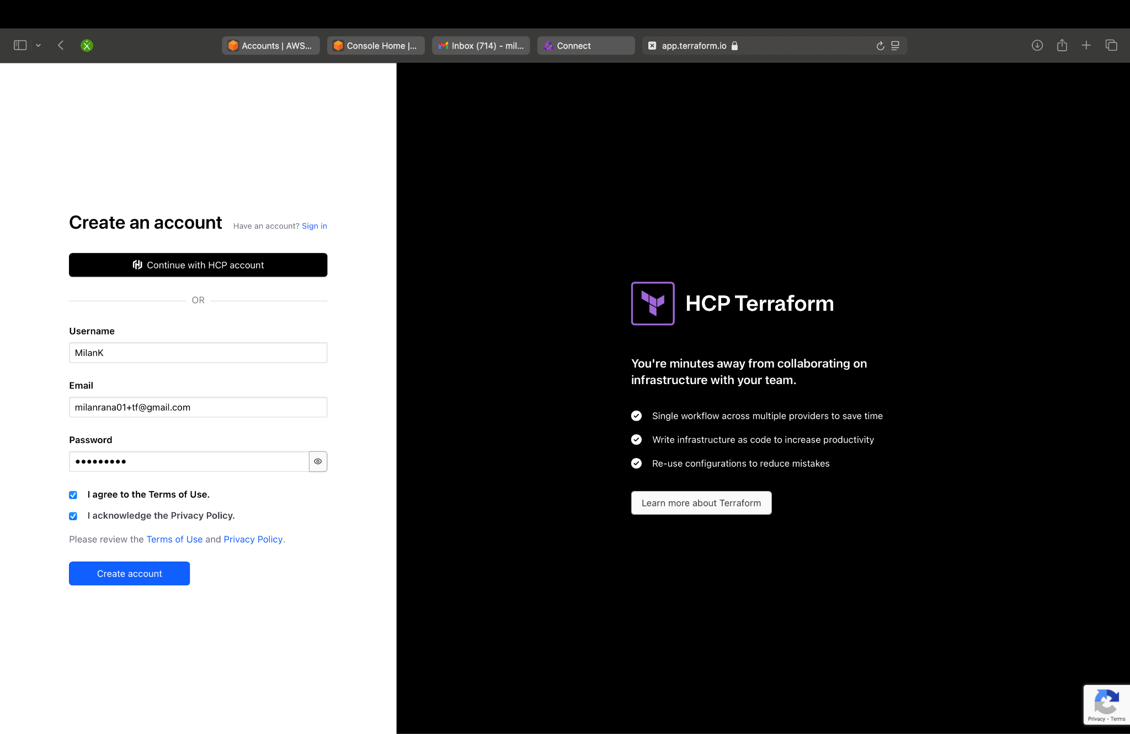

Once entered, you will be in the TFE Cloud, click on confirmation link that should send an email to you to verify

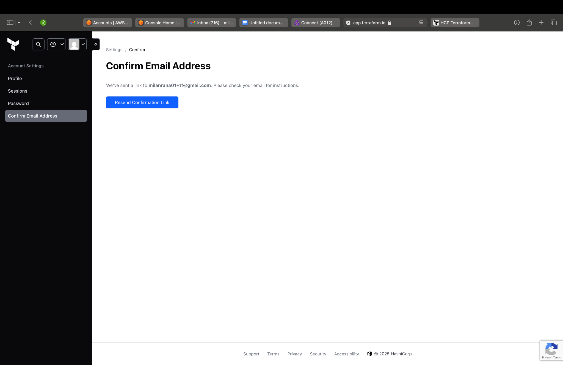

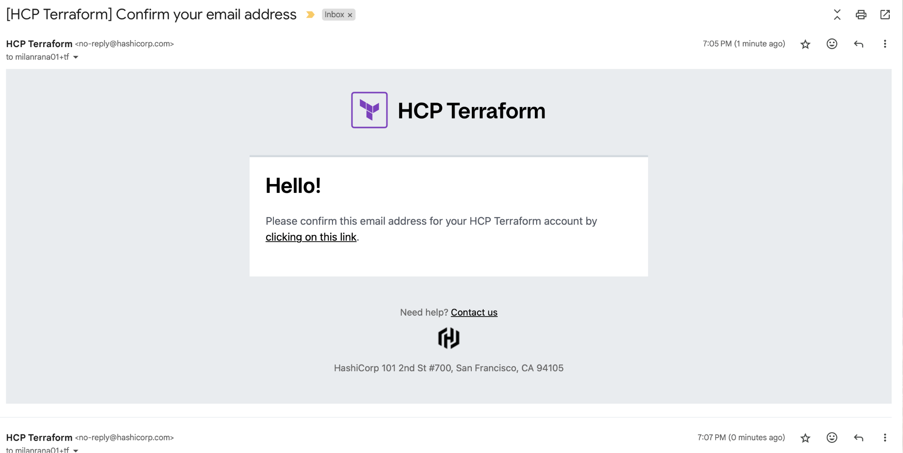

It takes you to the organization page that is basically a way Terraform let you manage organizations, projects, and teams.

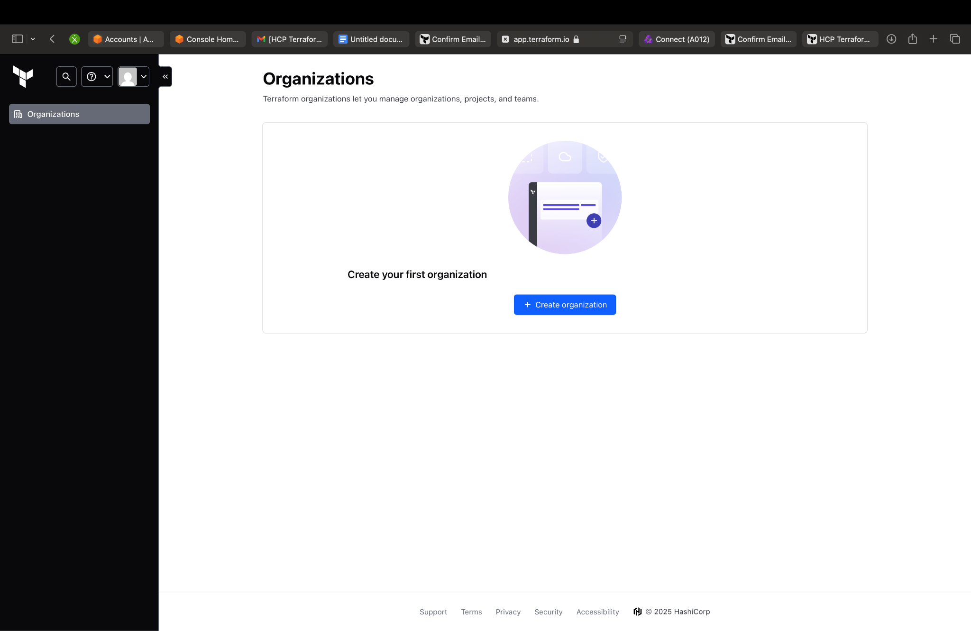

Enter Details to create the org.

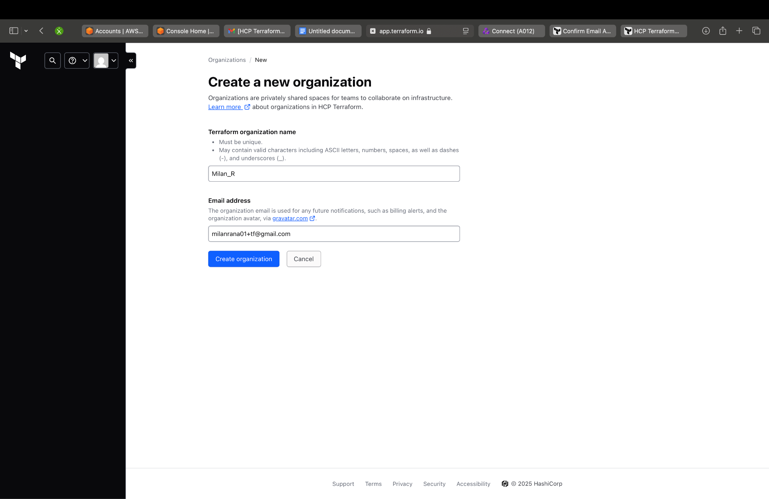

It should land you the below page, where we will be using the CLI driven workflow for the sake of this workshop

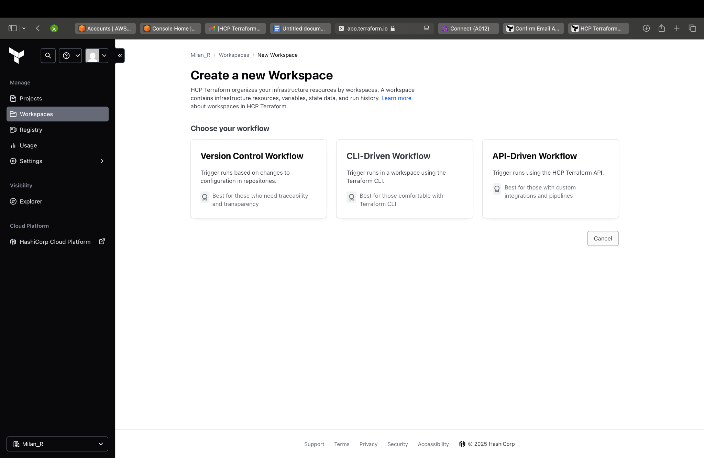

Selecting the cli driven option should take you to the page to create a workspace, enter details and click enter

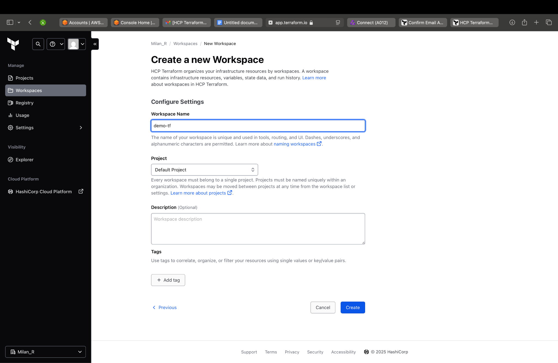

Once the Workspace gets created, you can follow further instructions in the below link to set up tf in your local and then we can connect our aws with tfe cloud.

Link-<https://developer.hashicorp.com/terraform/install#darwin>

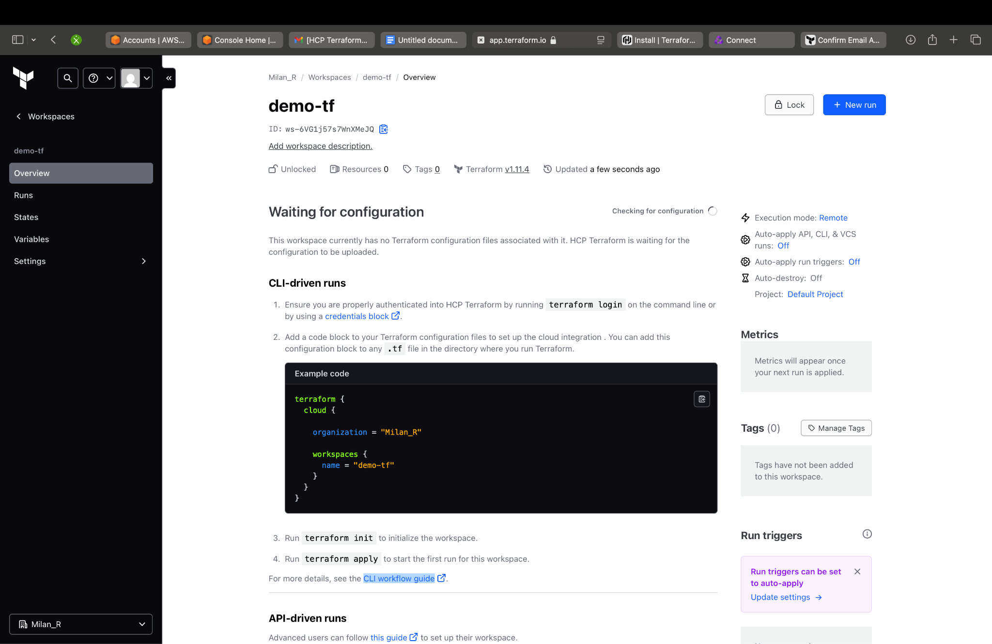

# Manual Terraform Installation

**1. Download Terraform** –

Visit the official download page: **https://developer.hashicorp.com/terraform/downloads**

**Choose the Correct Version**

* **Apple Silicon (M1/M2/M3)**: Select arm64 architecture
* **Intel Macs**: Select amd64 architecture

**2. Make Terraform System-Wide Accessible**

* Move the downloaded binary to your system PATH: -sudo mv terraform /usr/local/bin/

**3. Set Execute Permissions**

* Ensure the binary has execute permissions: - chmod +x /usr/local/bin/terraform

Note: Usually already has execute permissions, but this ensures it works

**4. Verify Installation**

Test that Terraforms is properly installed:

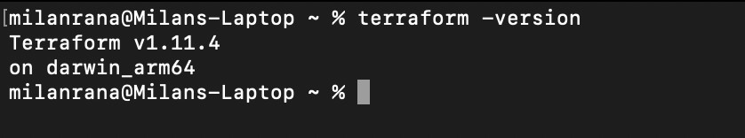

Alternative Verification Commands

* Check version (short form)

terraform -v

* Show help to confirm it's working

terraform --help

**Set Up at AWS end-**

Create a tfe user in your AWS account with AWS managed admin Policy

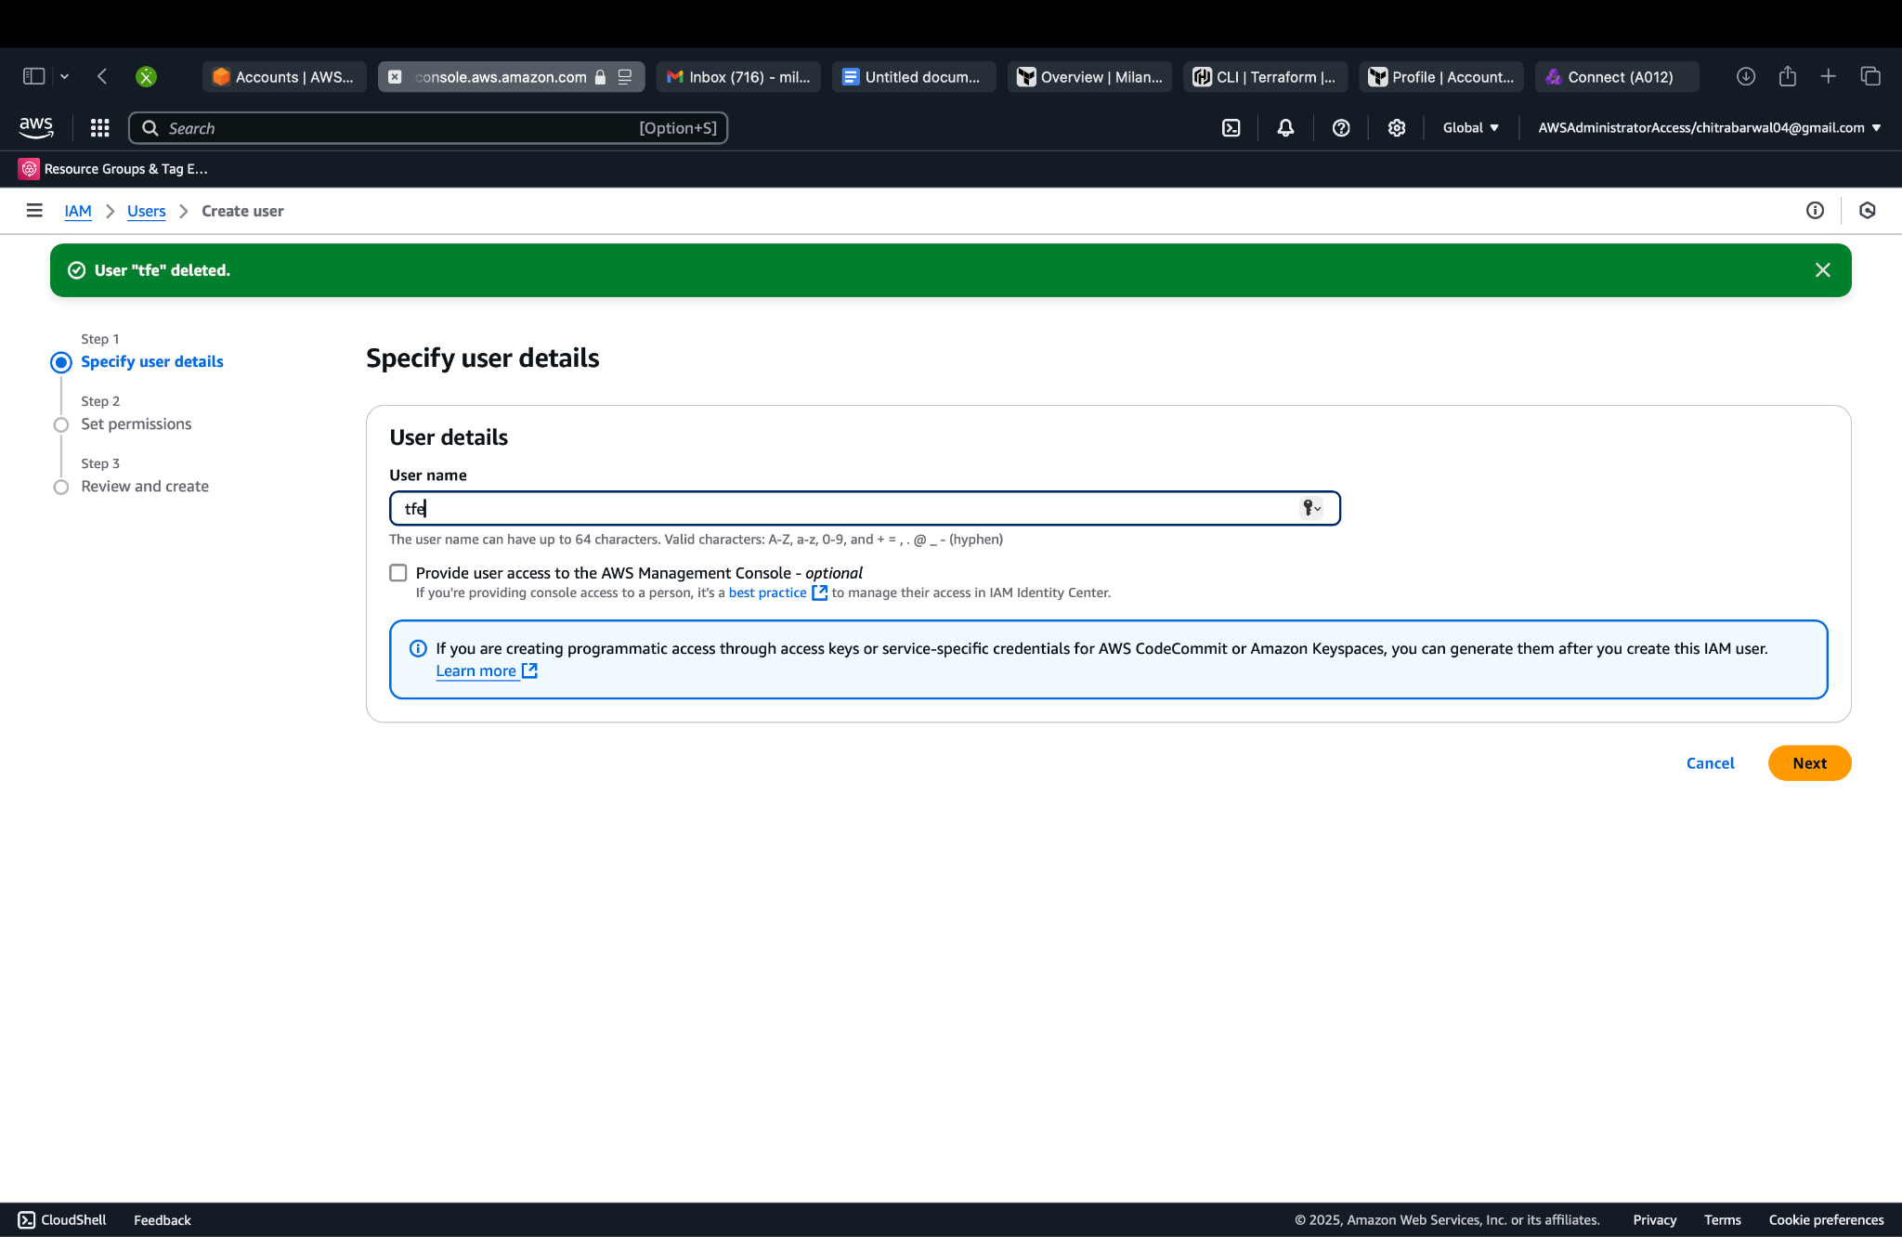

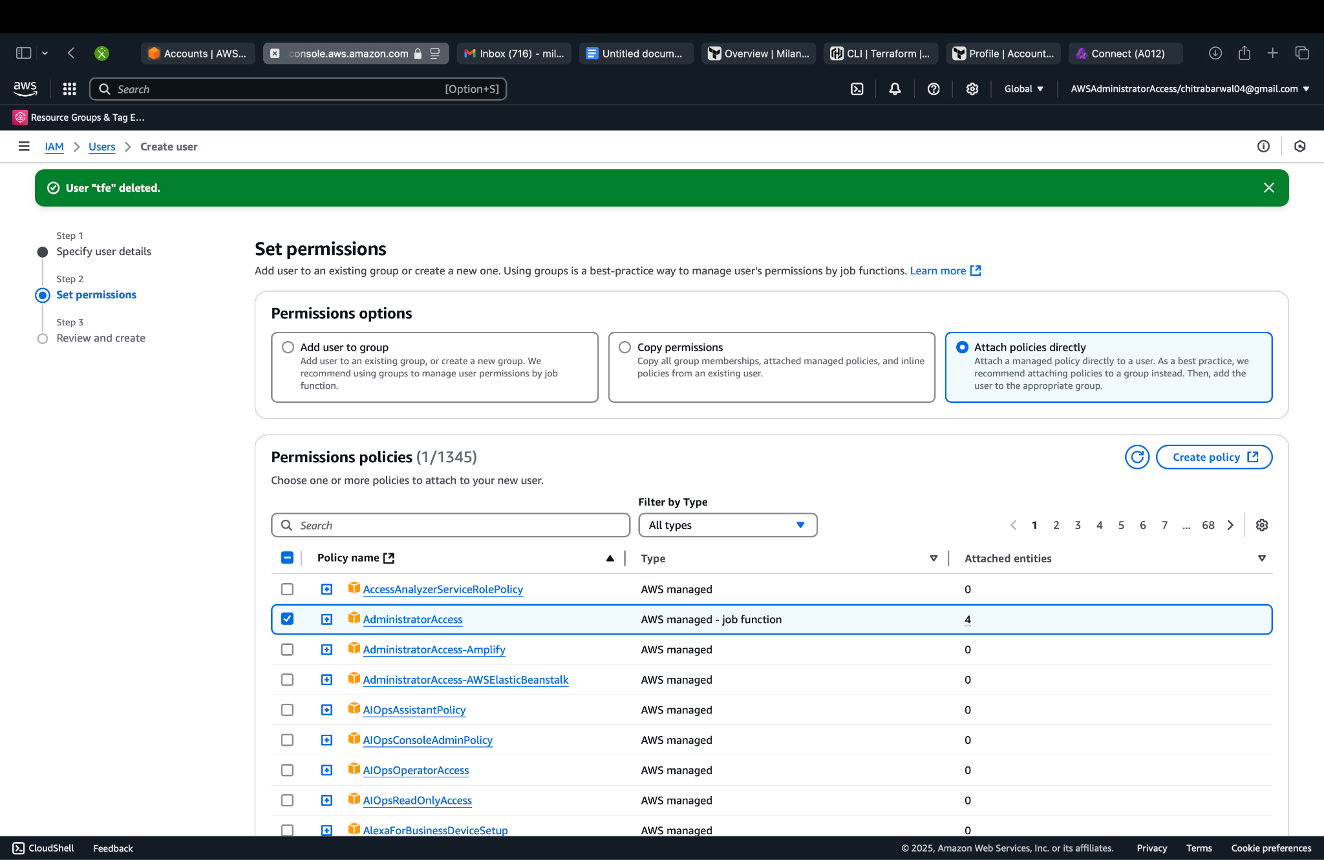

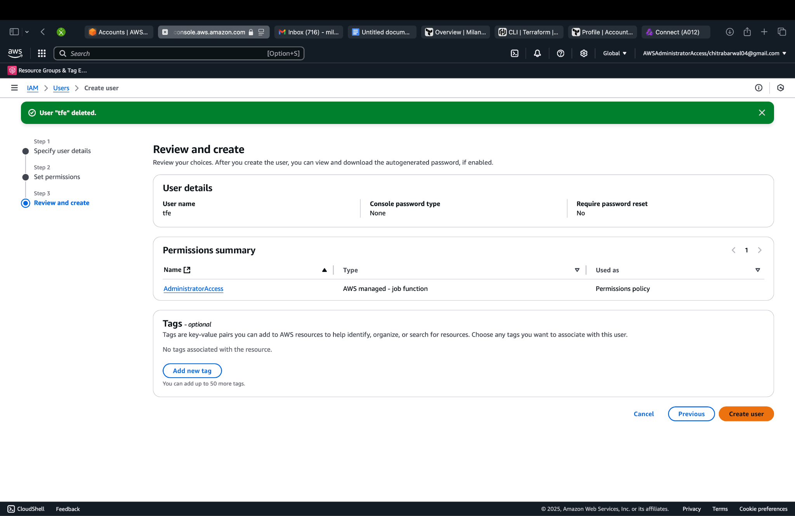

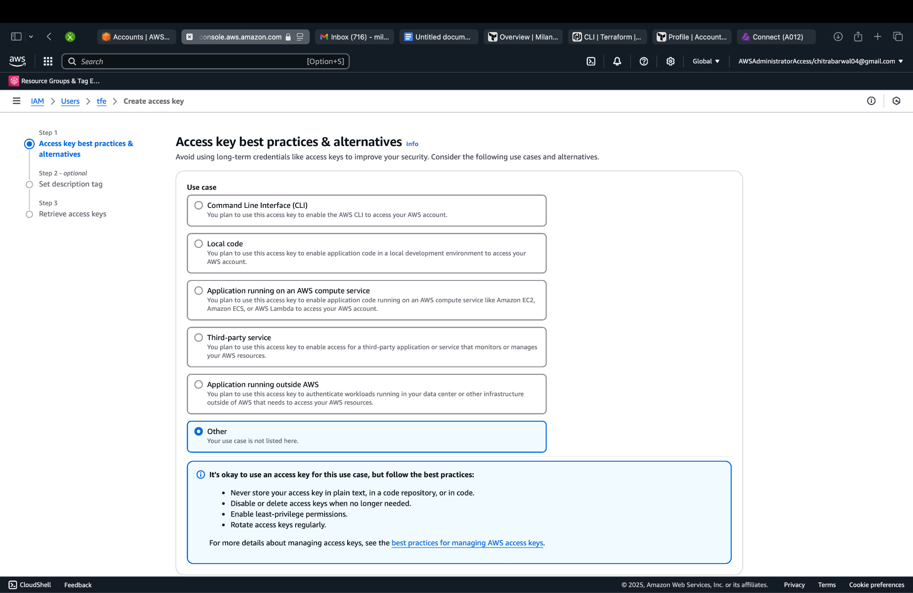

Note the secret Key and access key

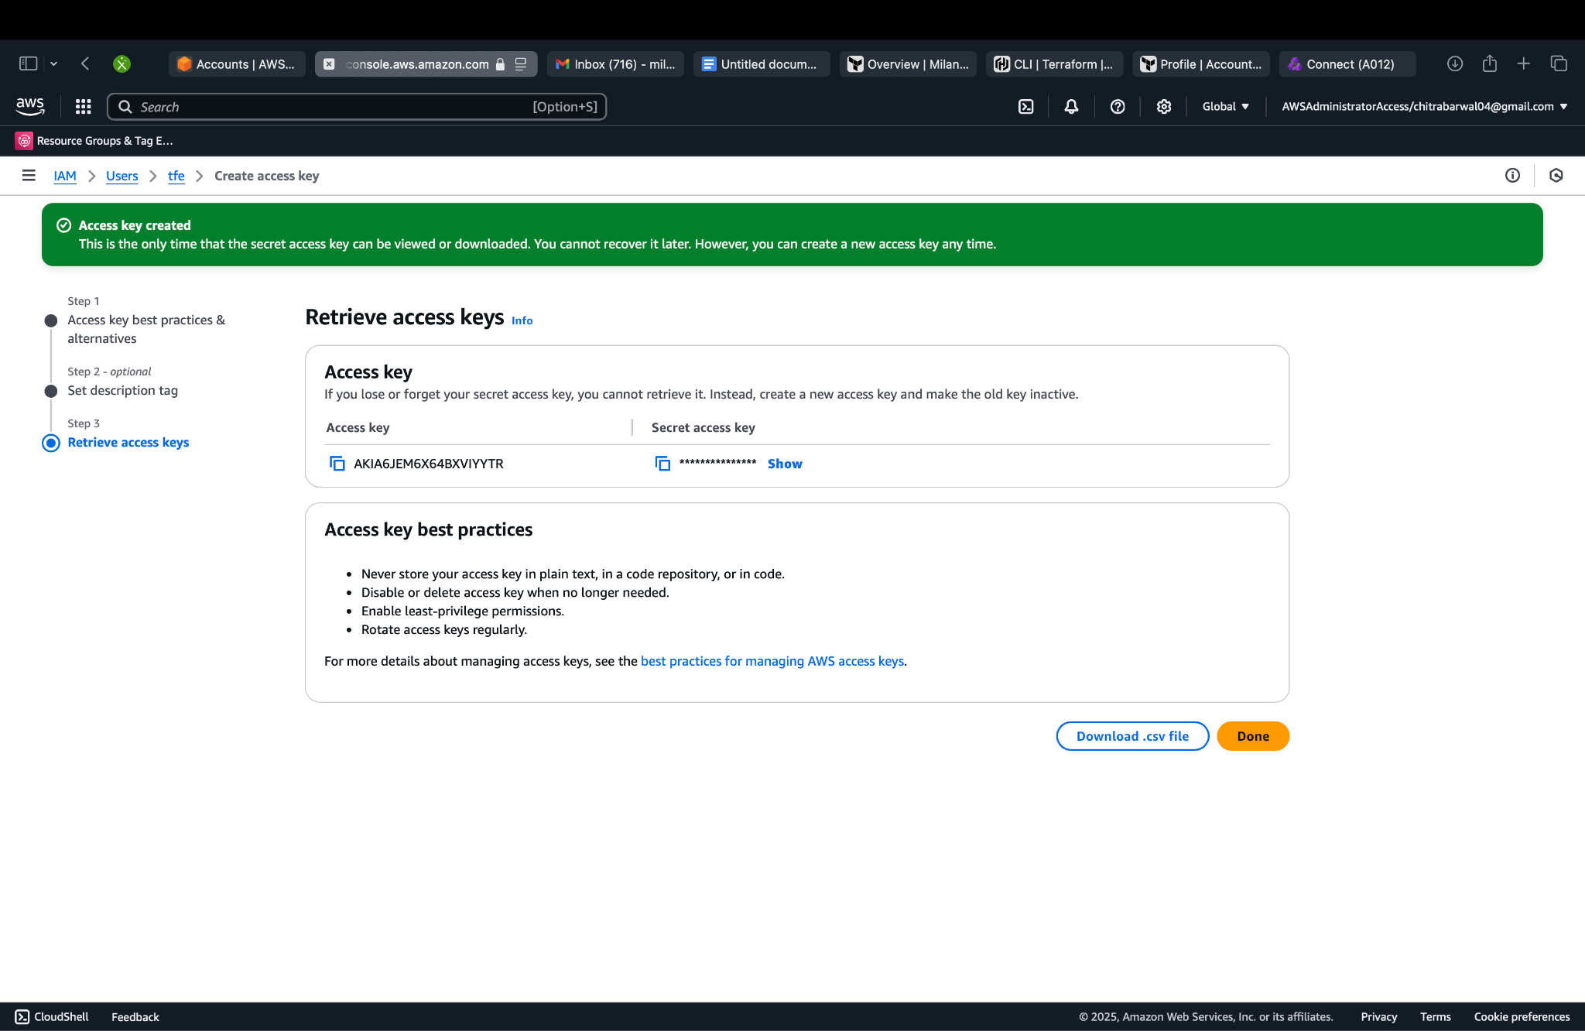

Go to your variable in workspace and create the following variables as shown.

You would need to enter the values of the access key and secret Key created in last step Here. This step basically links your AWS account and terraform.

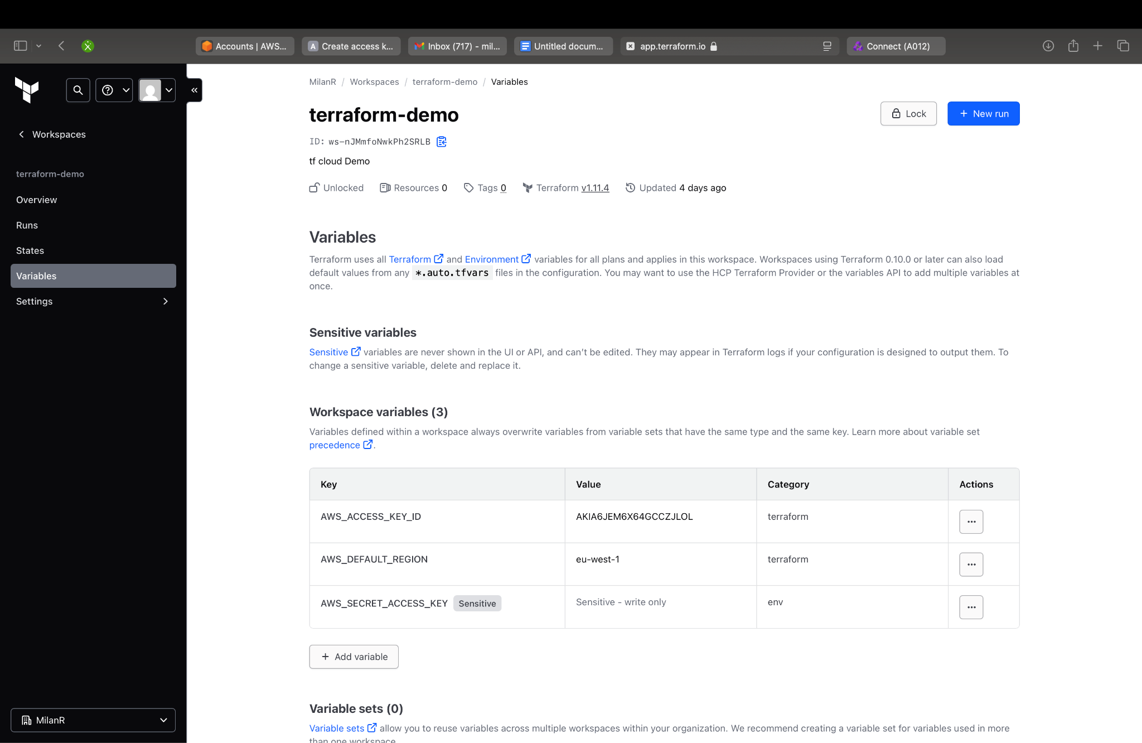

On terminal /cmd use command terraform login and yes to confirm

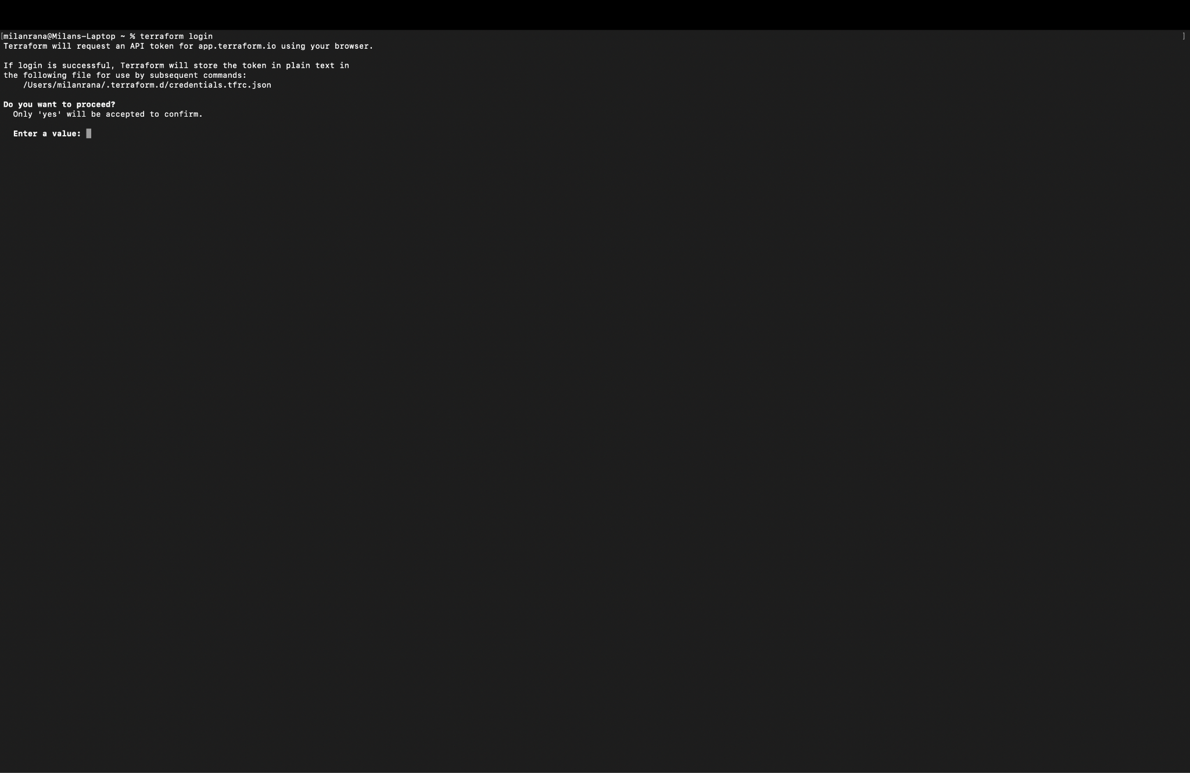

It should take u to generate a token on your tfe.

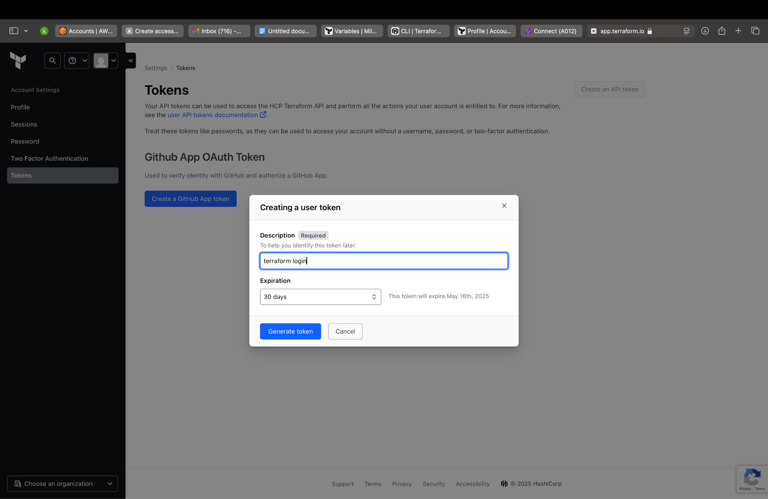

Copy the token generated and put it in termial/cmd

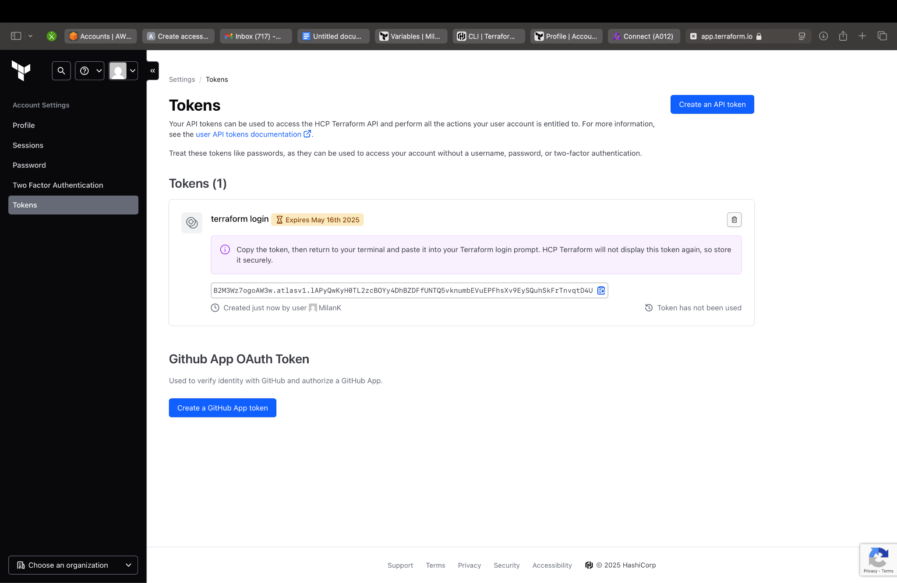

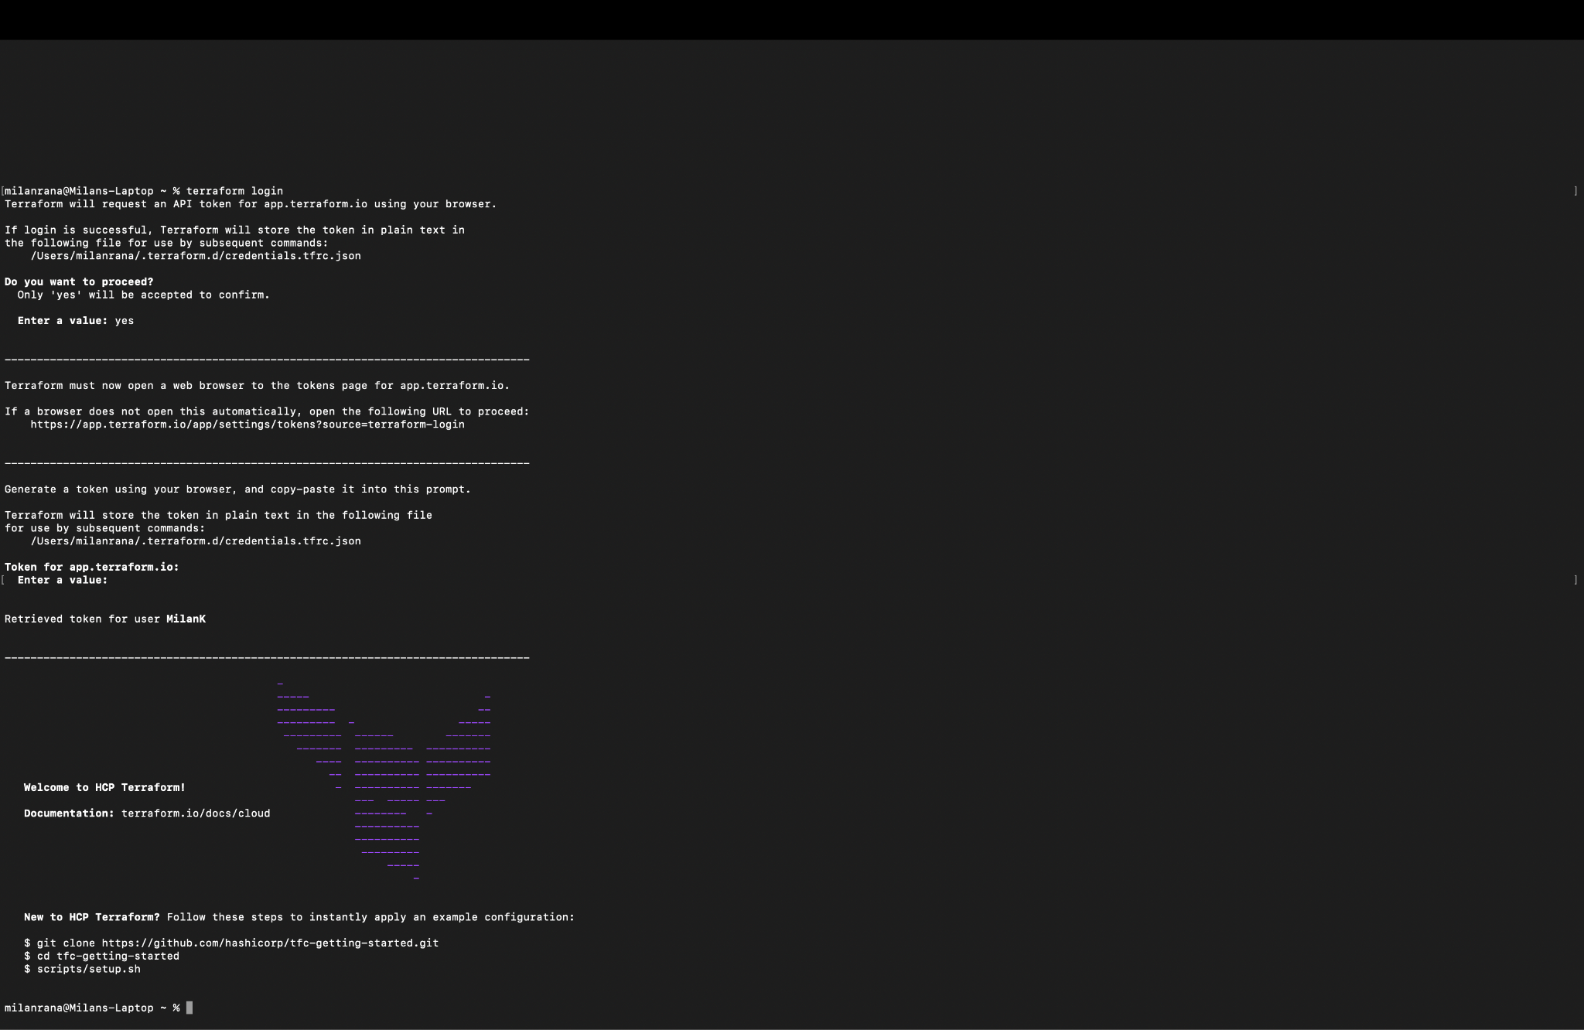

Create a folder for this demo and navigate into it

• Create a Terraform configuration file as per TFE workspace instructions

• Use vim <filename.tf> to create the file

• Press i to enter insert mode

• Paste the required configuration code

• Press Esc to exit insert mode  
• Type :wq! to save and exit the file

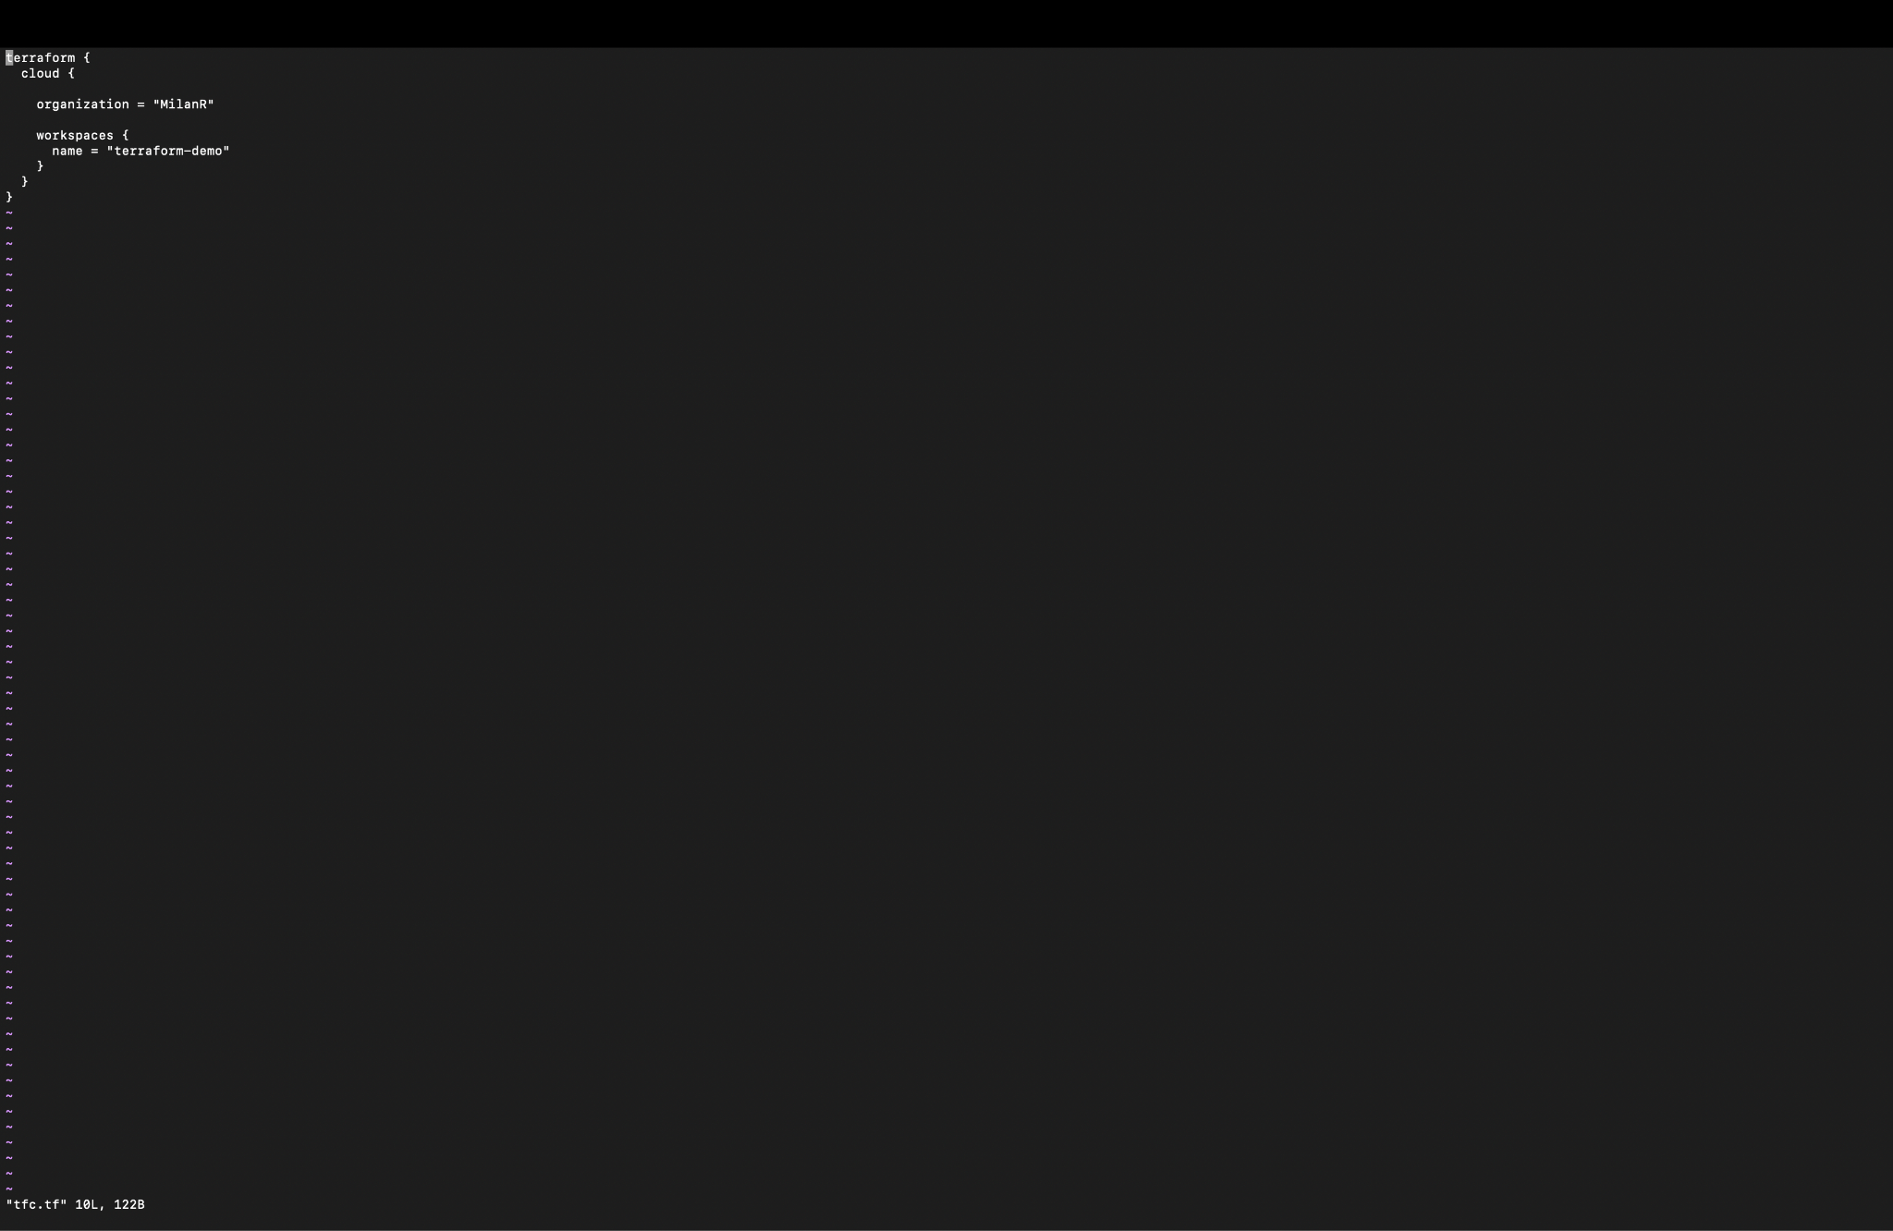

Once saved u can check the content of file using cat

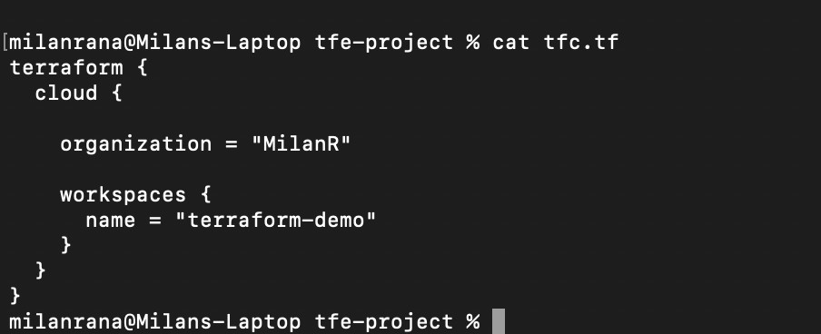

Similarly create a main.tf file to create your first resource as below and save the file and do cat to see if it is saved as per expectations

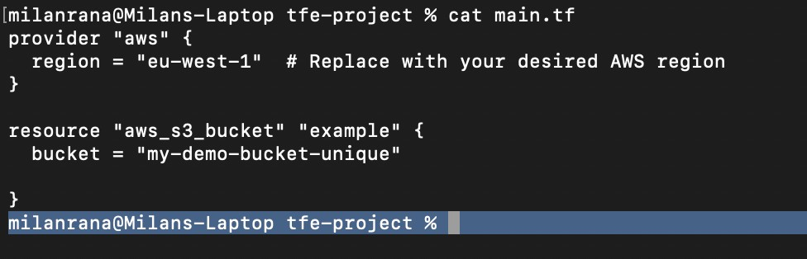

Run terraform init to initialize

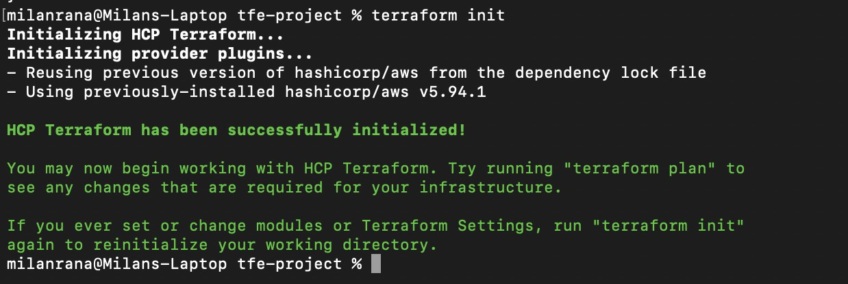

Followed by tfe plan

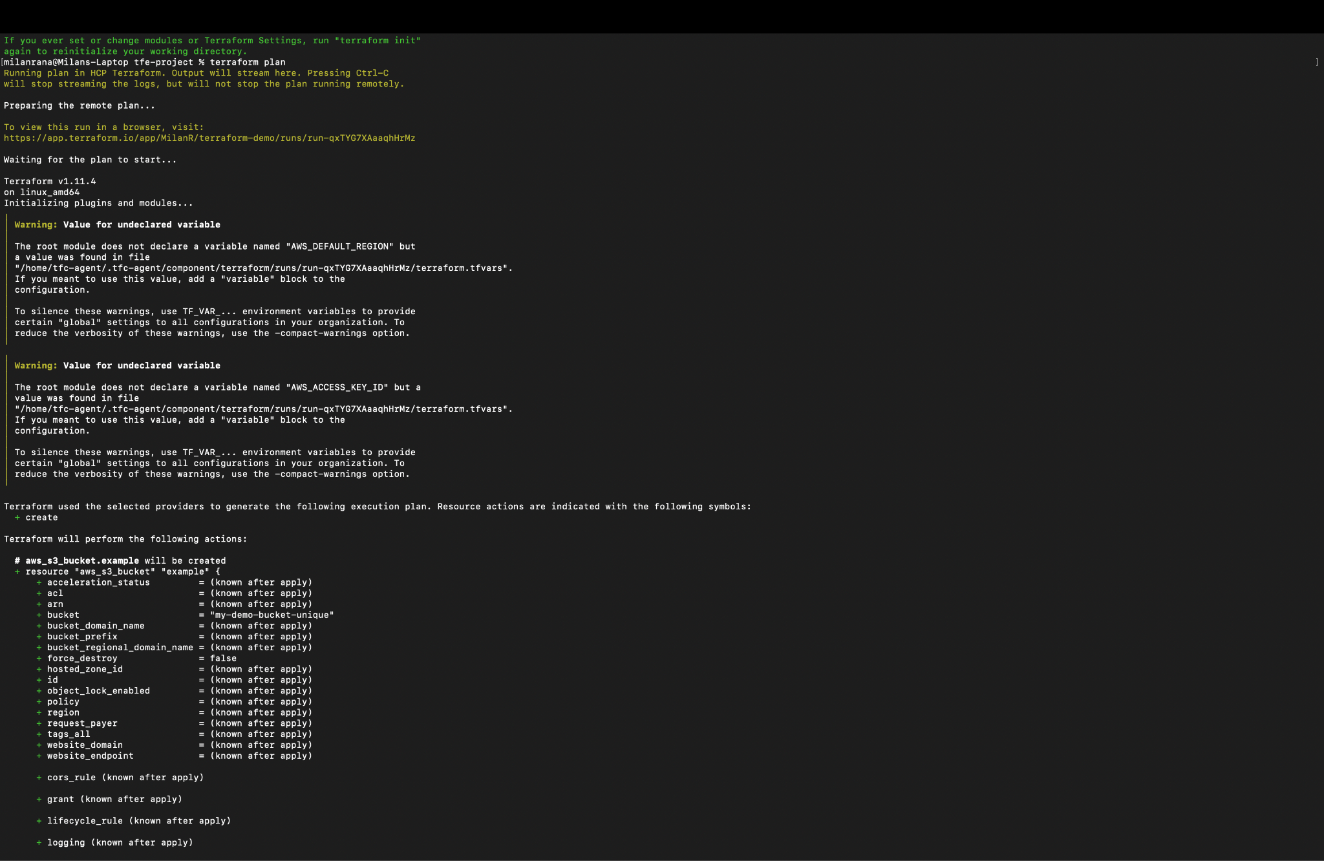

You can view the same in your workspace

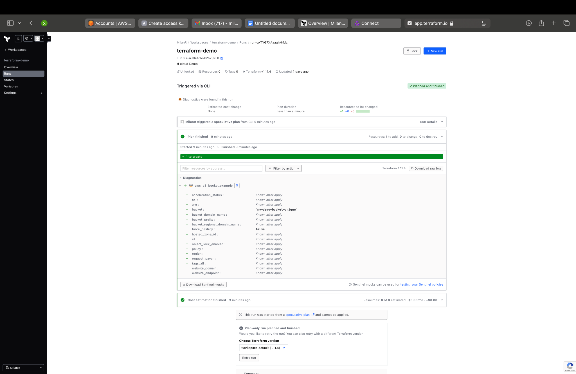

This will be followed by terraform apply

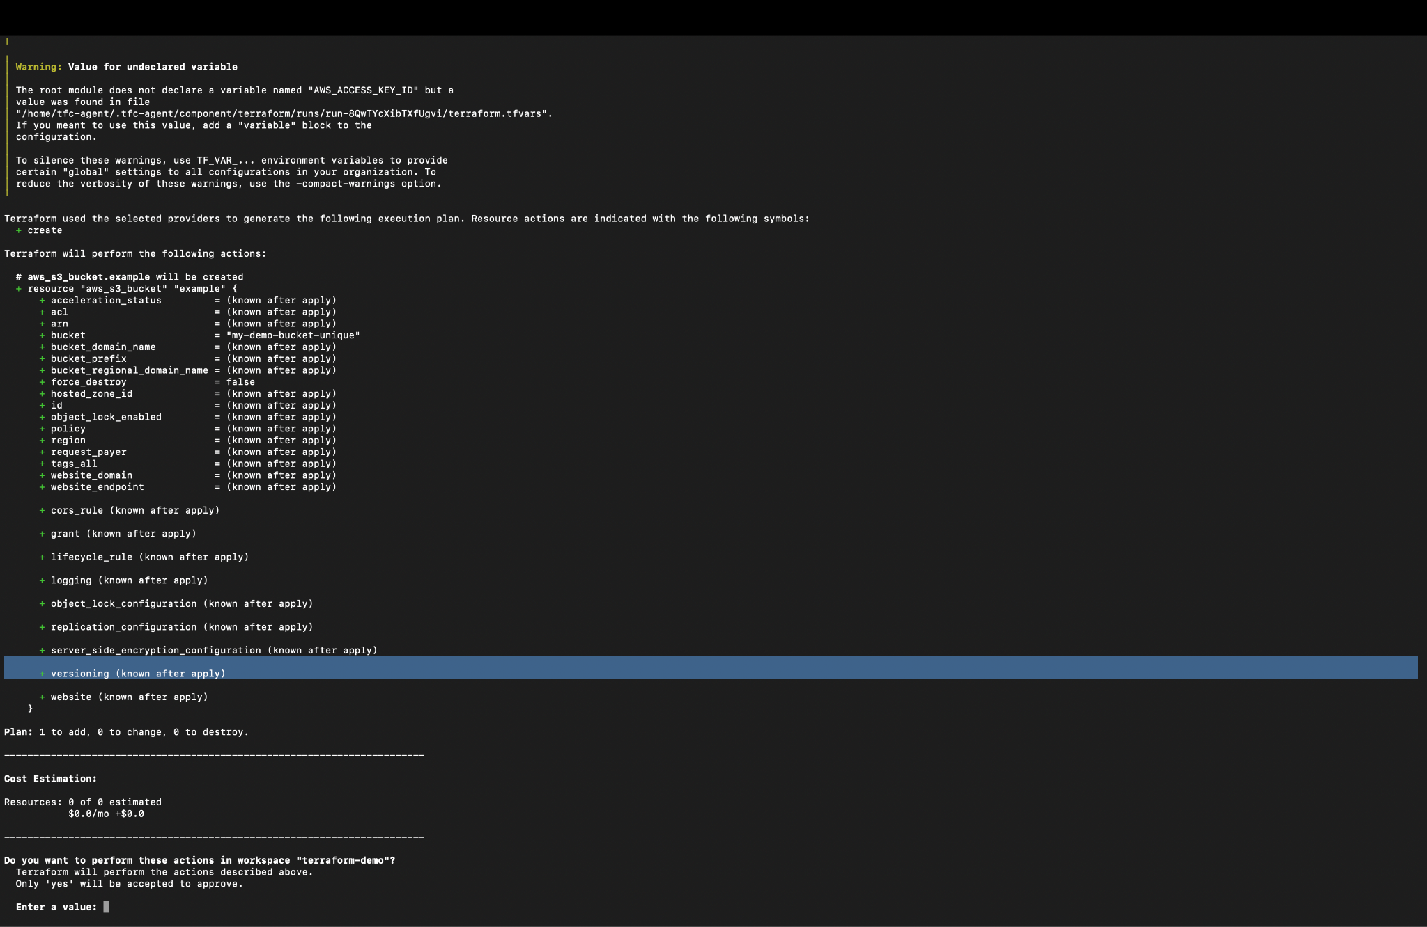

Similar view in UI, where you can confirm apply

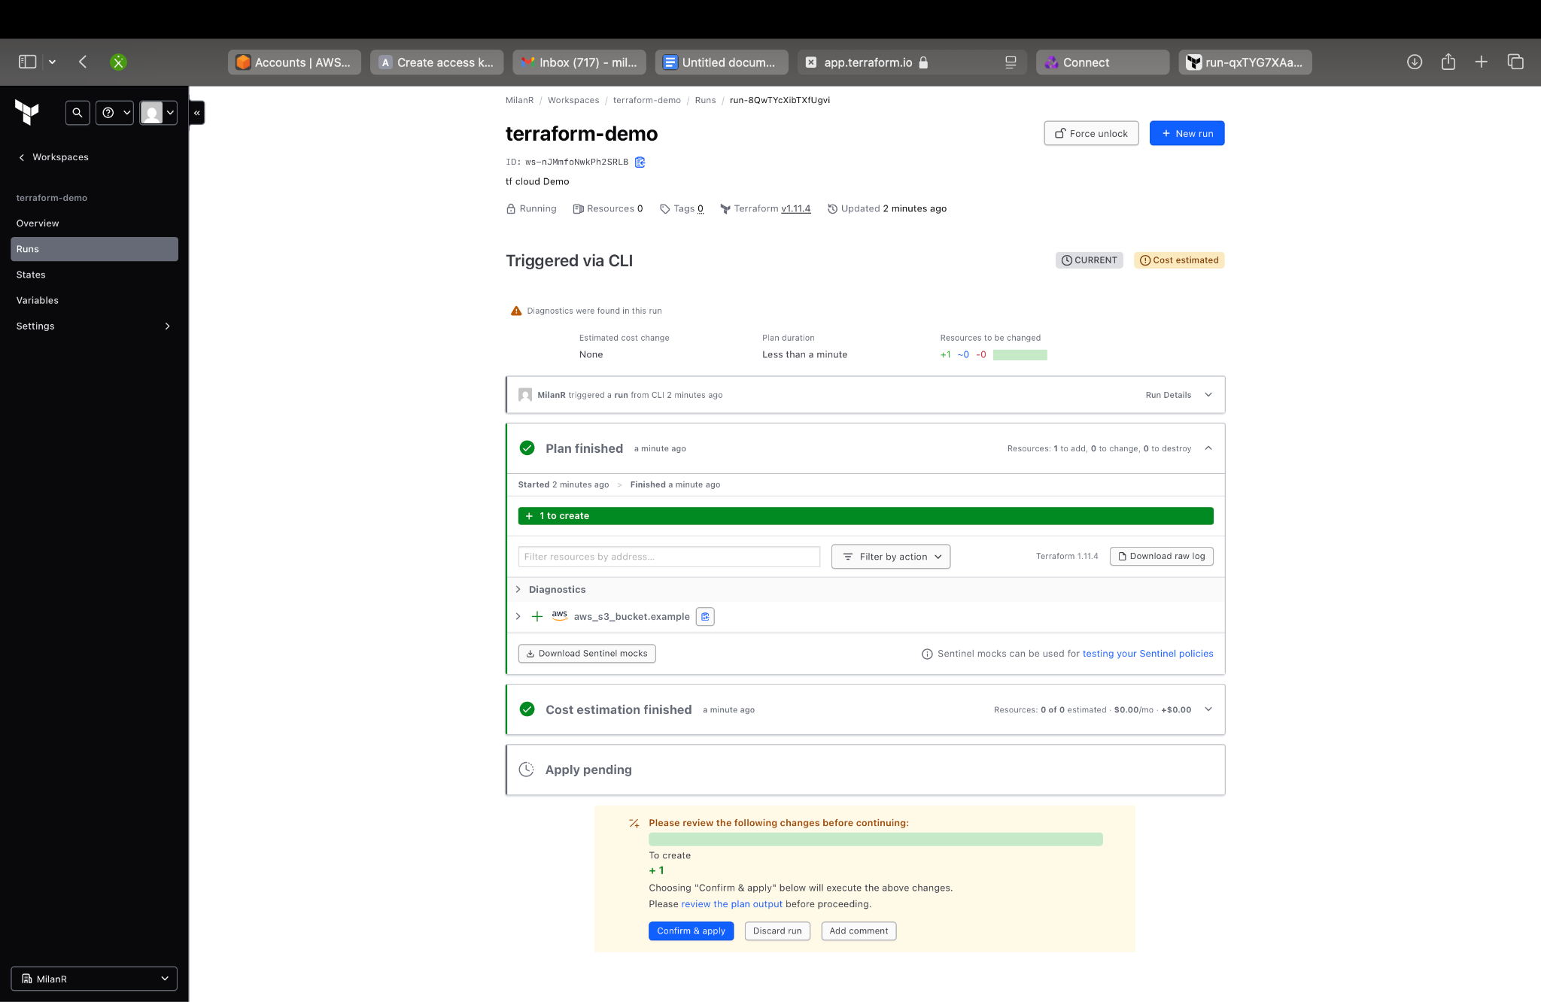

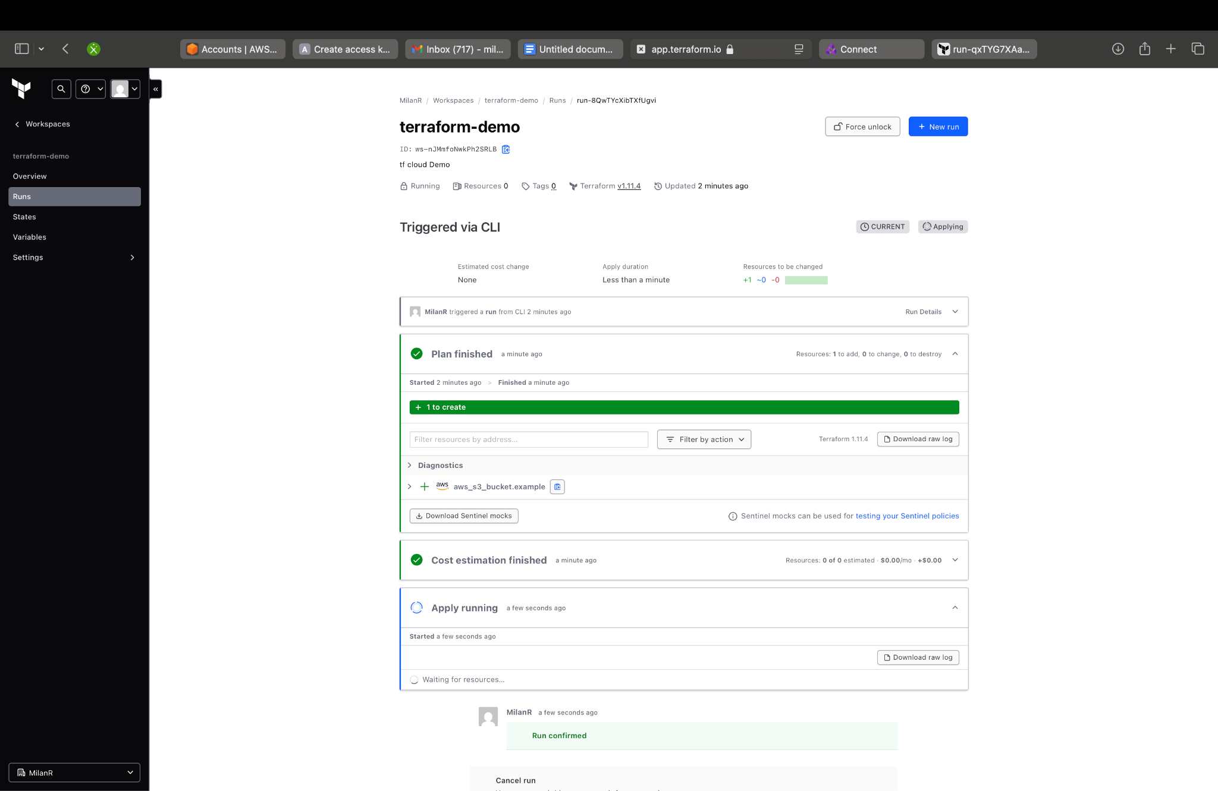

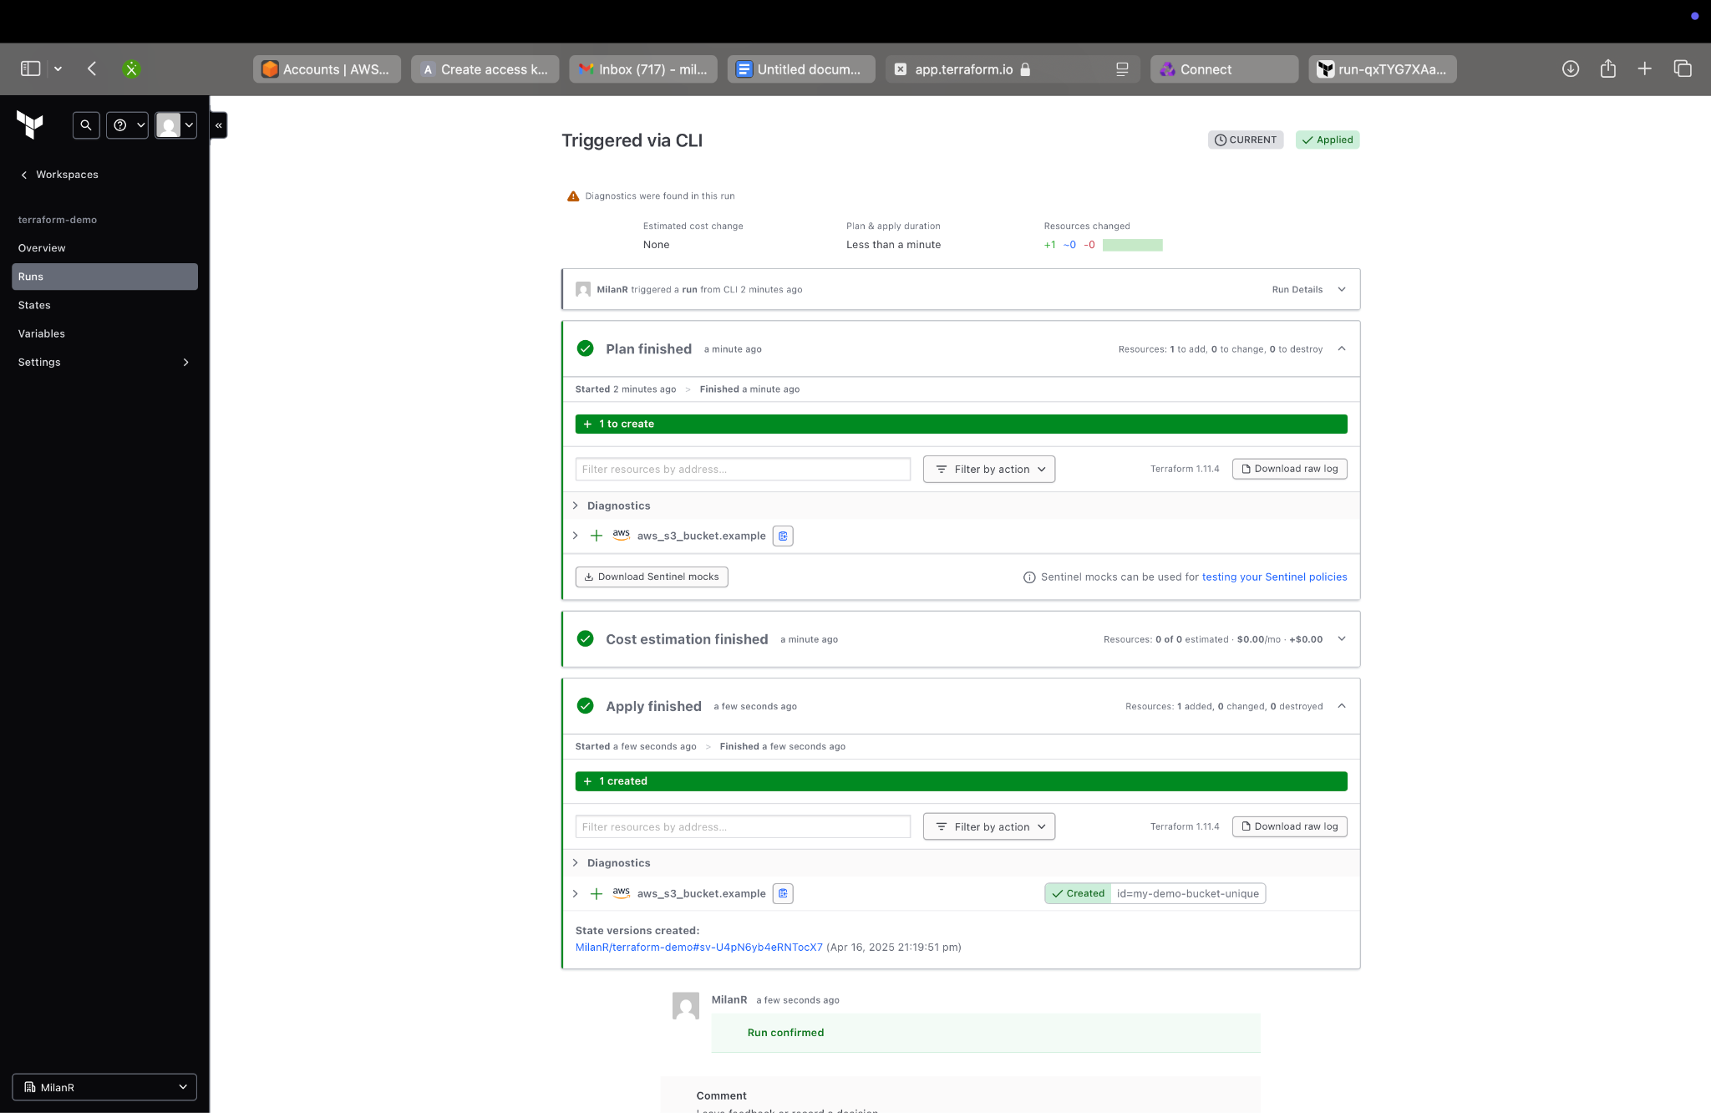

You can verify the same resource created in your AWS account by going to s3



